Please re-enter your participant label

Top of Form

Please re-enter your participant label below. This can be found in your original email.



Welcome

Top of Form

This is a study of **how people interact and make economic decisions in groups**. Please read the following participant information sheet carefully.

Participant Information Sheet

Our research team consists of Professor Chris Sibley, Professor Quentin Atkinson, and Professor Ananish Chaudhuri at the University of Auckland. This research is funded by a Royal Society of New Zealand Marsden Fund Grant.

You have been invited to participate in this study because you are a participant in the New Zealand Attitudes and Values Survey, and you have agreed to participate in an additional online study. You must be at least 18 years old to participate.

The purpose of this project is to assess **how people make economic decisions in groups.** In this study, we will ask you to make a series of decisions in a number of different tasks. In almost all of these tasks, you will be grouped with one or more other participants in this study. You will not learn the identity of any of these other individuals at any point either during or after the conclusion of the study, and they will not learn your identity.

The instructions for the tasks are simple, and based on the decisions that you make you will be reimbursed an appreciable amount of money. However, **this amount will depend on the decisions that you make and the decisions made by the other individuals you are interacting with.** You will need to make a series of decisions that differ from one task to the next. So please read the instructions carefully. We will ask you and every other participant to answer some comprehension questions before each task, to make sure that everyone understands how the tasks will work.

The entire study will take **approximately one hour**; possibly less. Please make sure that you have that time at your disposal. We will reimburse everyone $20 simply for participating in the study, as a thank you gesture for volunteering. We will also reimburse an additional amount depending on the decisions made by you and others undertaking the same task. This additional amount can vary from $10 to $35. However, on average we expect this bonus to be around $25. This means that, **on average, a participant can expect an overall reimbursement of around $45.** But the actual full amount may well be different based on the decisions you and others make.

Please understand that you will only be reimbursed this additional amount **if you complete the study.** If for some reason you are unable to complete the study in the allotted time, then you will only be reimbursed the initial $20 for participation.

*Please note: For reimbursement, the University of Auckland cannot apply withholding tax. It is therefore your responsibility to consider the tax treatment of this reimbursement, and determine whether you should include this amount within your annual tax return or personal tax summary.*

There are no known physical or psychological risks associated with this research. **The study has been approved by the University of Auckland Human Participants Ethics Committee.**Participation in this study is voluntary. You may withdraw from the study at any time without citing any reason. You can also withdraw from the study at a later date by emailing us (nzavs@auckland.ac.nz). In that case, we will delete any data pertaining to your decisions. Should you wish to do this, you must let us know within four weeks of your day of participation. You will need to tell us the date of your participation as well as your participant identification label.

At the end of the study, we will ask you for your **full name and bank details** to reimburse you. As soon as it is submitted, this information will be stored in an encrypted data file, which can only be accessed with a private key stored on a separate password-protected computer. This information will only be used for reimbursement purposes, and will be permanently deleted immediately after the reimbursement is processed by the University of Auckland. After reimbursement, nothing will directly connect you to your name or bank details. Your participant number will only be able to connect you to your previous NZAVS responses, which are anonymised.

The final anonymous data file from this study may be shared with other competent professionals on a case-by-case basis for research purposes. It will not be possible for others to identify your responses from this data or subsequent reports.

If you have any questions or concerns about this study, please contact Professor Chris Sibley (Phone: 09 923 8353; Email: nzavs@auckland.ac.nz) in the School of Psychology. You may also contact Professor Suzanne Purdy, Head of the School of Psychology (Phone: 09 923 2073; Email: sc.purdy@auckland.ac.nz).

For any queries regarding ethical concerns, you may contact the Chair, The University of Auckland Human Participants Ethics Committee, The University of Auckland, Office of the Vice Chancellor, Private Bag 92019, Auckland 1142. Telephone: 09 373 75 99 ext. 83711.

Approved by the University of Auckland Human Participants Ethics Committee on XX-XX- XXXX for (3) years. Protocol Number: xxxxx

By clicking Next, you understand that:

* You are agreeing to participate in this study.
* You are at least 18 years old.
* This is an online study that will take approximately one hour to complete.
* You will be reimbursed an initial $20 as a thank you gesture for volunteering your participation.
* You will be reimbursed an additional amount ranging between $10 and $35 (expected average $25) based on the decisions that you and the other participants make in this study. This additional amount will only be reimbursed if you complete the study; otherwise, you will only get the initial $20.
* For this reimbursement, the University cannot apply withholding tax. It is therefore your responsibility to consider the tax treatment of this reimbursement and determine whether you should include this amount within your annual tax return or personal tax summary.
* Your participation is completely voluntary.
* You are free to withdraw your participation at any time.
* At the end of the study, you will be required to submit your full name and bank details for reimbursement purposes.
* Your name and bank account number will be stored in an encrypted data file. It will be used solely to reimburse you, and will then immediately be deleted.
* Your responses will remain completely anonymous.
* Though data collected from this study may be presented at research conferences and published in scholarly outlets, your identity will never be revealed.

**Click Next to provide informed consent to take part in this study.**

**PLEASE READ THESE INSTRUCTIONS CAREFULLY!**

Thank you for participating in our study.

In this study, you will take part in **eight tasks**. These tasks all require you to make economic decisions in groups.

Each task will proceed as follows:

1. **Instructions.** You will read the instructions for the task. The instructions are different for every task, so make sure you read them carefully.
2. **Comprehension.** You will then answer a short comprehension question about the instructions, to make sure you have understood them.
3. **Decision(s).** Finally, you will make the decision(s) for the task. The decisions you make in each task will determine your bonus reimbursement for the study.

Some tasks will have different "roles" for different participants. We will ask you what you would like to do in each possible role.

The payoffs for each task will be given in points. Every ten points will be worth $0.35 at the end of the study. For example, a task for 100 points has $3.50 at stake.

**After you have completed all the tasks,** we will randomly match your decisions to the decisions of other **real people** taking part in this study at the same time. For each task, you will be matched with one or more other people. You will be re-matched randomly for every task, so the chance of you interacting with the same person in consecutive tasks is very small. You will never learn the identity of the people you are matched with. They will never learn your identity. The money that you are reimbursed from these tasks depends on the decisions that you and the other participants make.

**Every task will count towards your final payoff.** At the end of the study, after matching your decisions with those of other random participants, we will calculate what you earned in each task. The sum total of all these earnings will determine your bonus reimbursement from the study.

*Remember, this is not a survey you can pause and come back to later. You have 50 minutes to complete all the tasks, so please stay focused on the study. Otherwise, other participants may have to wait for you.*

**Please click Next to begin the tasks.**

Begin the tasks

Top of Form

**You will now begin the tasks.** The decisions you make from now on will determine how much you are reimbursed from this study.

Please click Next to continue to the first task.

Task 1 of 8

Top of Form

Please read the following instructions carefully.

Instructions

In this task you are matched with three other people.

All of you start with 100 points.

Each of you will choose whether to contribute 30 points to a group project.

All individuals decide at the same time.

If *all people* contribute, the group project is successful. In this case, all contributed points will be doubled and split evenly among the group.

If only one, two, or three people contribute, the group project is not successful, and all the points in it are lost.

The graphic below shows a summary of the task:

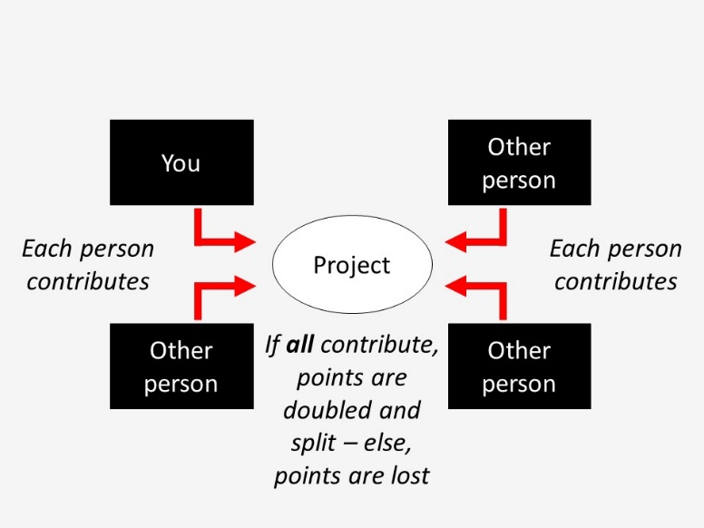

Bottom of Form

Bottom of Form

Before the task, please answer the following comprehension question carefully.

If you contribute 30 points to the group project, but no one else does, how many points do you end this task with?

*  130 points (100 start + 30)
*  100 points (100 start + 0)
*  70 points (100 start - 30)

Will you contribute 30 points to the group project?

*  Contribute 30 points
*  Do not contribute 30 points

Task 2 of 8

Top of Form

Please read the following instructions carefully.

Instructions

In this task you are matched with one other person.

One of you will be Person A, one of you will be Person B.

Both individuals start with 100 points.

This task has two phases. In each phase, both people choose at the same time.

The transfer phase

In the transfer phase, both people will choose whether to transfer 30 of their points to a group project or not. The group project is only successful if *both people* transfer points to it, in which case the 60 points in it will be doubled to 120 and distributed evenly between both people. If only one person transfers, the group project is not successful, and the points in it are lost.

The penalty phase

In the penalty phase, each person then chooses whether they want to remove up to 50 points from the other person, based on the other person's decision in the transfer phase. For every 5 points someone wants to remove from the other person, they must pay 1 point.

*NOTE: Removed points are completely removed from the task, they are not 'taken' by you.*

The graphic below shows a summary of the task:

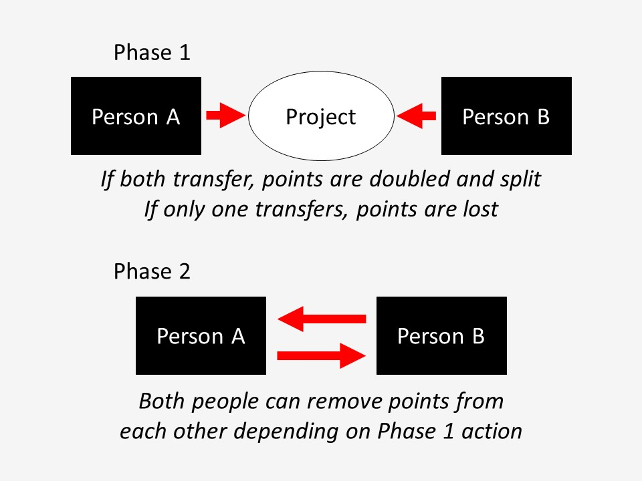

Before the task, please answer the following comprehension question carefully.

If you transfer 30 points to the group project, but the other person does not, how many points will you have at the end of the transfer phase?

*  130 points (100 start + 30)
*  100 points (100 start + 0)
*  70 points (100 start - 30)

Bottom of Form

Will you transfer 30 points to the group project?

*  Transfer 30 points
*  No transfer

Depending on the the other person's decision in Phase 1, how many points would you like to remove from them?

If the other DOES TRANSFER, I will remove this many points... [0 - 50]:

If the other DOESN'T TRANSFER, I will remove this many points... [0 - 50]:

Task 3 of 8

Top of Form

Please read the following instructions carefully.

Instructions

In this task you are matched with one other person.

One of you will be Person A, the other will be Person B.

Both of you start with 50 points.

First, Person A makes a choice, then Person B responds.

1. Person A can choose to transfer their 50 points or not. If Person A transfers 50 points then it is TRIPLED and given to Person B (so Person B now has 200 points).
2. Person B can then choose how many of the points they want to transfer back to Person A (between 0 and 150). This latter amount is not tripled.

The graphic below shows a summary of the task:

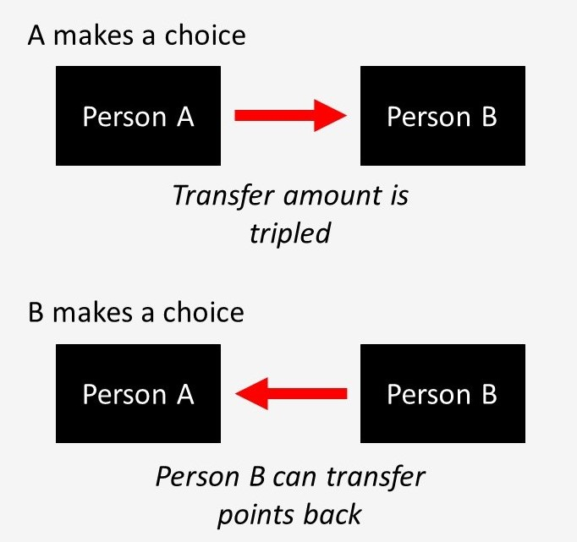

Bottom of Form

Before the task, please answer the following comprehension question carefully.

What happens if Person A transfers 50 points and Person B transfers back 25 points?

*  Person A earns 25 points, Person B earns 175 points
*  Person A earns 50 points, Person B earns 50 points
*  Person A earns 100 points, Person B earns 100 points

If you are Person A, do you want to transfer your 50 points to Person B?

*  No transfer
*  Transfer 50 points

If you are Person B and Person A transfers you 50 points (which is tripled to 150), how many points do you want to transfer back to A? [0 - 150]:

Task 4 of 8

Top of Form

Please read the following instructions carefully.

Instructions

In this task you are matched with three other people.

All of you start with 100 points.

Each of you will choose how much of these 100 points to contribute to a group project, and how much to keep for yourself.

All individuals decide at the same time.

All contributed points are doubled and split evenly among the group.

Thus, for every 2 points you contribute, you only receive one point from the project. So contributing more points always increases your groups' total payoff, but you always end up with more money if you contribute less.

The graphic below shows a summary of the task:

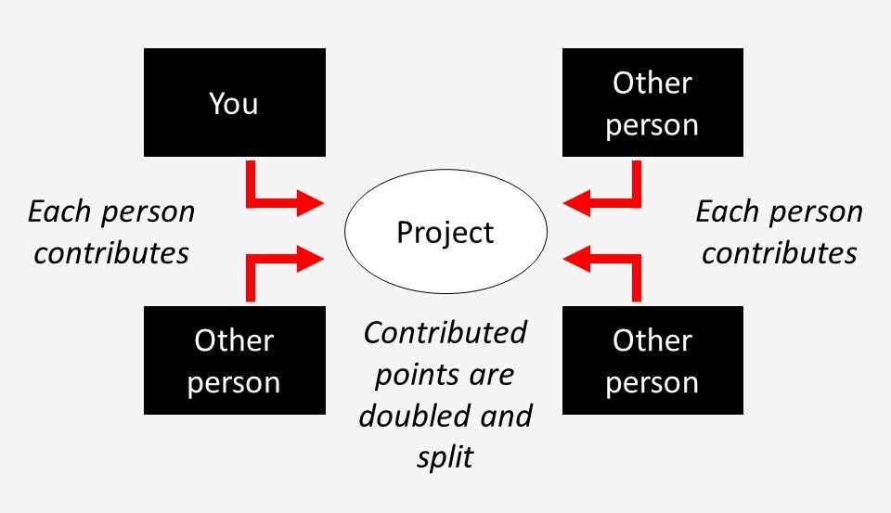

Bottom of Form

Before the task, please answer the following comprehension question carefully.

What contribution BY YOU maximises payoffs for the GROUP? What about for yourself?

*  Contributing 100 maximises payoffs for both the group and myself
*  Contributing 0 maximises payoffs for both the group and myself
*  Contributing 100 maximises payoffs for the group but contributing 0 maximises my own payoff

How many points do you wish to contribute to the group project? [0 - 100]:

## Task 5 of 8

Top of Form

Please read the following instructions carefully.

### Instructions

In this task you are matched with one other person.

One of you will be Person A, one of you will be Person B.

Person A starts with 100 points and Person B starts with 0 points.

First Person A makes a choice, then Person B responds.

1. Person A will make an offer on how to split the 100 points with Person B.
2. Person B will either accept or reject this offer. If Person B accepts the offer, then B will get the offered amount and A will keep the rest. If Person B rejects the offer then both individuals will get 0 points.

The graphic below shows a summary of the task:

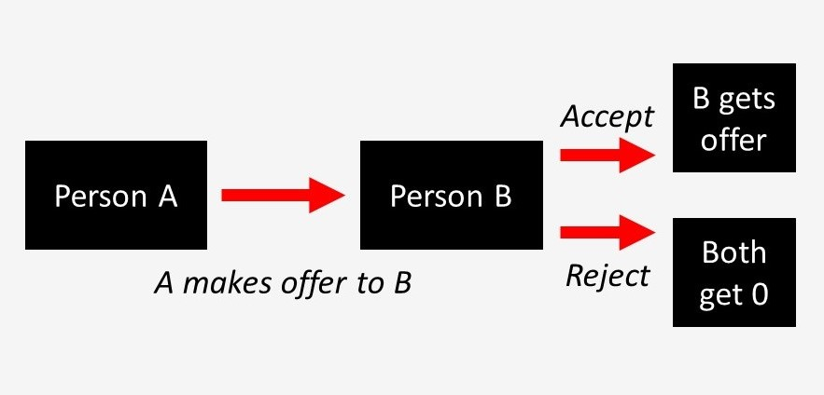

Before the task, please answer the following comprehension question carefully.

What happens if Person B accepts an offer of 20 points? What happens if Person B rejects this offer?

*  If B accepts this offer then A gets 80 and B gets 20, if B rejects then A gets 80 and B gets 0
*  If B accepts this offer than A gets 0 and B gets 0, if B rejects then A gets 0 and B gets 0
*  If B accepts this offer then A gets 80 and B gets 20, if B rejects then both get 0

If you are Person A, what amount will you offer to Person B? [0 - 100]:

If you are Person B, what is your minimum acceptable offer? That is, if the offer that Person A gives you is below this, you would reject and if the offer A gives you is above or equal to this, you would accept. [0 - 100]:

Task 6 of 8

Top of Form

Please read the following instructions carefully.

Instructions

In this task you are matched with one other person.

One of you will be Person A, one of you will be Person B.

Person A starts with 100 points, and Person B starts with 0 points.

This task has one single decision: Person A will choose how many of the 100 points to transfer to Person B.

Person B will get the number of points Person A transfers, and Person A will get to keep the rest.

The graphic below shows a summary of the task:

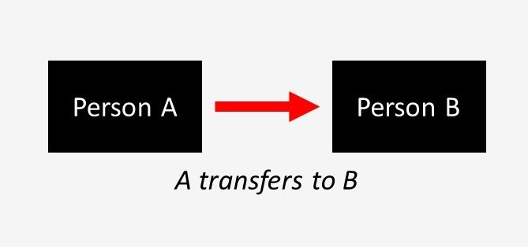

Bottom of Form

Before the task, please answer the following comprehension question carefully.

What happens if Person A transfers 20 points?

*  A keeps 80 points and B gets 20 points
*  Both get 20 points

If you are Person A, how many points will you transfer to Person B? [0 - 100]:

## Task 7 of 8

Top of Form

Please read the following instructions carefully.

### Instructions

In this task you are matched with two other people.

One of you will be Person A, one of you will be Person B, one of you will be Person C.

All individuals start with 100 points.

First, Person A makes a choice, then Person C responds.

1. Person A can choose to take or not take from Person B.
2. If A takes, Person B loses 50 points and A gains 30 points.
3. If A takes, then Person C can choose to remove points from A. Person C can remove up to 100 points from A.

Person C must pay 1 point for every 5 points they remove from A. Person B is passive in this task and makes no decisions.

*NOTE: Removed points are completely removed from the task, they are not 'taken' by Person C.*

The graphic below shows a summary of the task:

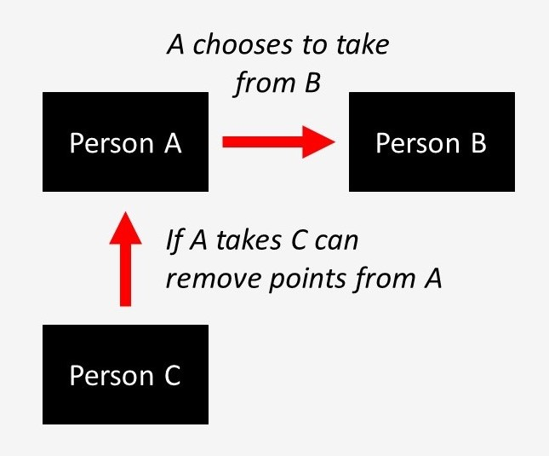

Before the task, please answer the following comprehension question carefully.

When can Person C remove points from Person A?

*  C can only choose to remove points from A if A chooses to take
*  C can always remove points from A
*  C can never remove points from A

If you are Person A, will you take from Person B?

*  Don't take
*  Take

Bottom of Form

If you are Person C, how many points will you remove from Person A if they take? [0 - 100] (Reminder: if A chooses to take, B loses 50 points and A gains 30 points.):

Task 8 of 8

Top of Form

Please read the following instructions carefully.

Instructions

In this task you are matched with one other person.

One of you will be Person A, one of you will be Person B.

Both individuals start with 100 points.

This task has two phases. In each phase, both people choose at the same time.

The transfer phase

In the transfer phase, both people will choose to transfer 30 of their points to the other person or not. Any points transferred are doubled and given to the other person.

The penalty phase

In the penalty phase, each person then chooses whether they want to remove up to 50 points from the other person, based on the other person's decision in the transfer phase. For every 5 points someone wants to remove from the other person, they must pay 1 point.

*NOTE: Removed points are completely removed from the task, they are not 'taken' by you.*

The graphic below shows a summary of the task:

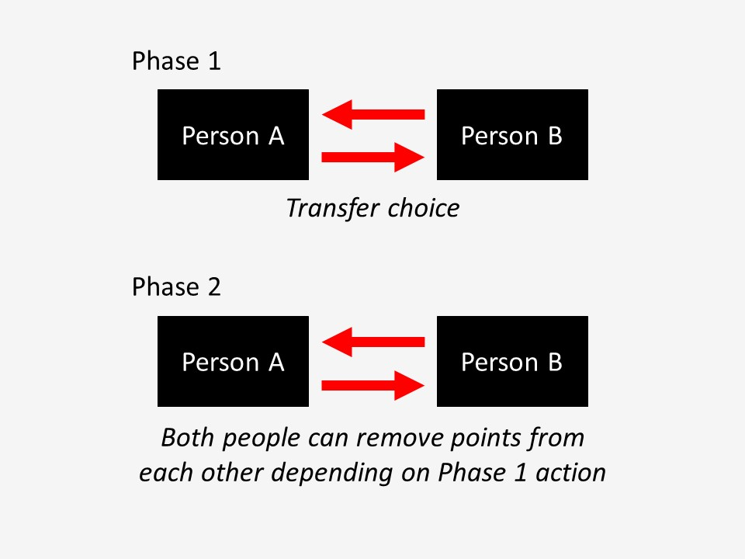

Bottom of Form

Before the task, please answer the following comprehension question carefully.

If Person B transfers and Person A doesn't, how many points will they each have at the end of the transfer phase?

*  A will have 100 (100 start - 0 transferred), B will have 130 (100 start - 30 transferred + 60 received)
*  A will have 160 (100 start + 60 received - 0 transferred), B will have 70 (100 start - 30 transferred)
*  Both will have 130

Will you transfer 30 points to the other person?

*  Transfer
*  Don't transfer

Bottom of Form

Bottom of Form

Depending on if the other person transfers, how many points would you like to remove from them?

If the other DOES TRANSFER, I will remove this many points... [0 - 50]:

If the other DOESN'T TRANSFER, I will remove this many points... [0 - 50]:

#### **Matching you to other participants... please wait!**

**3/4** participants are already here...

Waiting for **1** more participant...

Time until the end of the session: **xx:xx**

Thank you for completing all the tasks. We are now randomly matching you with other participants, in real-time. Since some participants are slower than others, please be patient while we wait for them to complete the tasks too. We apologise if this takes some time. However, if anyone takes longer than the allotted time, we will skip them forward to this screen, so you shouldn't have to wait too long.

**NOTE: Please leave this window open for the full allotted time. You may leave your computer while you wait, but please make sure this window stays open. After this screen, you can finish the rest of the study at your own pace.**

After this screen, we will show you the results of all the games, and your payoffs. You will then be required to enter your bank account information for reimbursement.

Payoffs

Top of Form

**We have successfully matched you to other participants.** In the rare event that we could not find a participant to match you with, we have instead matched you with average decisions based on previous research.

For each task, we randomly assigned you to a role (if there were multiple roles) and determined the payoffs for you and the participant(s) you were matched to.

Below are the results of each of the tasks.

Task 1

In this task, all four people started with 100 points.

You chose not to contribute 30 points to the group project.

Overall, only 3 group members contributed, and so the group project was unsuccessful. All points in it were lost.

Your payoff for this task was **100 points**.

Task 2

In this task, both people started with 100 points.

In Phase 1, you chose not to transfer 30 points to the group project, but the other person did. The group project was unsuccessful, and so the points in the group project were lost. At the end of Phase 1, therefore, your payoff was 100 points.

You did not remove any points from the other person for their choice in Phase 1.

The other person removed 30 points from you.

Your payoff from both phases of this task was **70 points**.

Task 3

In this task, you were assigned the role of Person A. Both people started with 50 points.

You transferred your 50 points to Person B, which was multiplied to 150 points. Person B then sent back 75 points.

Your payoff for this task was **75 points**.

Task 4

In this task, all four people started with 100 points.

You contributed 0 points to the group project. The other group members contributed 30 points, 30 points, and 30 points. The total number of points was doubled and divided evenly between all people. This was added to your remaining points.

Your payoff for this task was **145 points**.

Task 5

In this task, you were assigned the role of Person B. Person A started with 100 points and you started with nothing.

Person A offered you 40 points. Your minimum acceptable offer of 0 points was below this, and so you accepted their offer.

Your payoff for this task was **40 points**.

Task 6

In this task, you were assigned the role of Person A. You started with 100 points and Person B started with nothing.

You transferred 0 points to Person B.

Your payoff for this task was **100 points**.

Task 7

In this task, you were assigned the role of Person C. All people started with 100 points.

Person A chose not to take any points from Person B. As a result, you did not remove any points from Person A.

Your payoff for this task was **100 points**.

Task 8

In this task, both people started with 100 points.

In Phase 1, the other person transferred 30 points to you (doubled to 60 points), but you did not transfer anything. At the end of Phase 1, therefore, your payoff was 160 points.

You did not remove any points from the other person for their decision in Phase 1.

The other person removed 30 points from you.

Your payoff from both phases of this task was **130 points**.

**Your overall payoff from all tasks was 760 points. This means that your bonus for the study is $26.60. This will be added to your initial show-up fee of $20.00, giving you an overall reimbursement of $46.60 for this study.**

If for some reason, your bonus for the study ended up less than $10, then we have rounded it up to $10.

Click Next to see a summary of your reimbursement for the whole study, and to provide your bank account details.

Bottom of Form

Reimbursement

Top of Form

In total, you will be reimbursed **$46.60** for this study ($20.00 plus $26.60).

In order to reimburse you this money, we now need to ask you for your name and NZ bank account number. This information will be stored in an encrypted data file, which can only be accessed with a private key stored on a separate password-protected computer. This information will only be used for reimbursement purposes, and will be permanently deleted immediately after the reimbursement is processed by the University of Auckland. After reimbursement, nothing will directly connect you to your name or bank details.

Please enter your first name:



Please enter your last name:



Please enter your NZ bank account number. We will transfer your reimbursement into this account, so please make sure it is correct. Please enter it in the following format: 00-0000-0000000-000. You may need to add a leading zero to the last three digits.



**Please double-check that all these details are correct before continuing.** After clicking Next, you *cannot* re-submit this information.

Next

Bottom of Form

## Reimbursement

These are the details you just submitted to us. Please double-check that they are correct.

First name: **scott**

Last name: **claessens**

NZ bank account number: **00-0000-0000000-000**

Are these details correct? If not, please let us know and we will get in touch.

*  Yes, these details are correct
*  No, these details are not correct

## Reimbursement

Top of Form

Thank you for informing us that the reimbursement details you supplied us are incorrect. We will send you an email after the study following this up.

If you would like to tell us what exactly went wrong, you can let us know in the feedback form on the next page.

Bottom of Form

Feedback

Top of Form

If you would like to leave us any feedback about this study, please do so below:



Next

## Future studies

Top of Form

Would you like to be contacted about future studies similar to this one?

*  Yes
*  No

Please re-enter your participant label

Top of Form

Please re-enter your participant label below. This can be found in your original email.



Bottom of Form

Please re-enter your participant label

Top of Form

The participant label you entered does not match the one you entered at the start of the study. Please double-check your email, and try entering the participant label one more time. It is very important that you enter the correct participant label, as we will use this to match your responses here with your previous NZAVS responses.

Bottom of Form

## Thank you for your participation!

Top of Form

The study is over.

Thank you for supplying your reimbursement information. Reimbursement will be processed on the Friday after your participation. Please allow five working days from then for the reimbursement to reach you. If you have any questions about this reimbursement process, or the study in general, please get in touch (nzavs@auckland.ac.nz).

You may now close your browser and exit the study.

Bottom of Form